Harmony Extensible Schema Matcher:
User and Developer Guide

Joel Korb, Chris Wolf, Peter Mork, and Len Seligman
The MITRE Corporation
October 17, 2006

Table of Contents

1. Installing and Running Harmony 1
2. Selecting Schemas 1
3. Viewing Schemas 2
4. Linking Schemas 3
6. Importing/Exporting Options 5
Appendix 1: Extending Harmony 5
A. Schema Loader 6
B. Match Voter 6
C. Vote Merger 7
D. Importer 7
E. Exporter 8

1. Installing and Running Harmony
To install Harmony, one only needs to determine which directory they wish to install Harmony into and then unzip Harmony.zip into this directory. To run Harmony, it must first be ascertained that Java 5.0 or above is installed on their machine and that the environment variable “java” is assigned as the path of this java executable. Once verified, one can run Java simply by double-clicking on the Harmony.bat file.

2. Selecting Schemas
When starting a new project, there are initially no schemas associated with the project. Thus, the first screen seen looks much like what is shown in Figure 2.1.
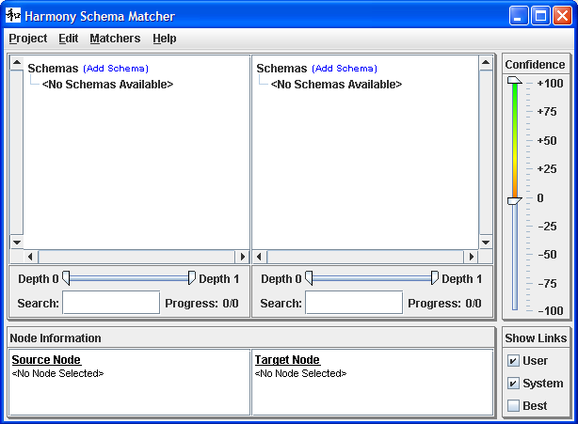
Figure 2.1 – Initial Harmony View
From here, the user has the option to add source and target schemas to the project. Source schemas are shown on the left while target schemas are shown on the right. The primary difference between source and target schemas is that source schemas are typically thought of as the schemas which one wishes to merge together and target schemas are thought of as the centralized schemas into which the source schemas are being merged.
The process of adding a schema is relatively straightforward. First, the user must click on the “Add Schema” option found at the top of both the source and target schema windows. This will then open up a file selection window which allows one to select a schema. Only schemas that are formatted in a way known to the Harmony converters may be used. Currently, Harmony ships with schema converters for .xsd, .owl, and .rdf files. The user may always develop new converters for use within Harmony to expand this set. Instructions on doing this are provided in Appendix 1.
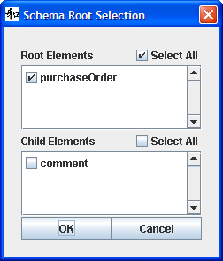
Figure 2.2 – Element Selection
Once the schema file is selected, the schema is examined to find all of the defined schema elements. If more than one schema element is found, the user is asked to indicate which schema elements should be included within the project. This is done through the dialog box shown in Figure 2.2. The elements are broken down into two separate groups. Root elements are those elements which are not defined as children of any other element. Children elements, on the other hand, are those elements which are defined as a descendant of at least one of the root elements.
These selections are not permanent and can be changed at any time during the running of Harmony by right-clicking on the schema and selecting the “Edit Schema” option. Additionally, schemas can be removed throughout the running of Harmony by right-clicking on the schema and selecting the “Remove Schema” option. One final note on the selection of schemas is that these selections are dynamic in nature. Thus, any changes made to the schema file will be reflected in Harmony the next time that this application is launched. Likewise, deleting a schema file will cause Harmony to lose the schema. In such cases, Harmony will query the user for the new location of the schema when the project is reopened.

3. Viewing Schemas
Once schemas are loaded into Harmony, there are several viewing options which help the user examine the structure of the schema. The first and most obvious method for examination is by expanding and collapsing the schema elements which are displayed in a treelike structure. The elements selected by the user when loading the schema are displayed at the topmost level of this tree while all child elements are represented as branches in the tree. In this way, the user can easily trace the linage of any element back through its parents. The expansion and collapse of the various nodes can be expedited by right clicking on any element and selecting the “Expand All” and “Collapse All” options. This will expand or collapse all children elements of the selected element.
Beyond the top-level viewing of element names, the user can delve deeper into the details of any of the schema elements. This can be done by simply clicking on the schema element for which more information is desired. Doing so displays the relevant element information in the “Node Information” window found at the bottom of Harmony and shown in Figure 3.1. This information includes the element’s name, description, type, attributes, and domain values. Note that each of these particular pieces of information will only be displayed if the schema converter used for the specific schema handles the extraction of such information. Otherwise, these fields will not be displayed.
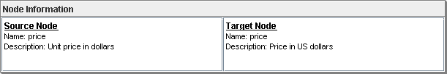
Figure 3.1 – Node Information Window
One additional way of exploring the structure of the schema is through the search pane. This handles keyword searches across the displayed schemas. If the user wishes to find all schema elements which use the word “Time” in their name, they can type this word into the window. When the search is executed, all matching elements are highlighted in yellow and marks are placed on the scrollbar to indicate any matches that were found outside of the currently viewed part of the schema. The asterisk wildcard character is also available for use within this search window. Thus, if one wishes to find all schema elements that contain the word “New*Time”, matched items could include such items as “NewStartTime”, “NewStartingTime”, as well as “NewClosingTime”.

4. Linking Schemas
To create a single link between a source and target schema is simple. One only needs to left click on a node element and drag the mouse to the linked node element. A line is displayed between the two items and a linkage has been defined. But this only scratches the surface of the possibilities available when linking schemas.
For one thing, attempting to generate all of these schemas by hand is an arduous process to say the least. Supposing that one is dealing with linking a source and target schema of 1000 elements a piece, the user has 1,000,000 possibilities for linkages which must be examined. Thus, with this being an unfeasible solution, automated matchers can be used to assist in the making of these linkages.
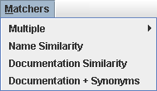
Figure 4.1 – Matchers Dropdown
To run a matcher, the user can use the “Matchers” menu item found at the top of the Harmony application. This dropdown is shown in Figure 4.1. From this list, two types of matchers are available. The first type of matcher is a “Match Voter”. The “Name Similarity” matcher, “Documentation Similarity” matcher, and “Documentation + Synonyms” matcher are all Match Voters. These types of matchers provide confidence scores indicating how confident they are in elements being associated with one another. These confidence scores range from -1 which means “definitely not a match” to 1 which means “definitely a match”. The second type of matcher is a “Vote Merger” of which only the “Multiple” matcher is part of. Instead of actually calculating confidence scores, this type of matcher retrieves results from Match Voters and then merges these results together through an algorithm. The resultant set of confidence scores is what is then returned. When using Vote Mergers, the user is provided with the option of either merging together all of the Match Voters or selectively picking which Match Voters to merge together. Additional Match Voters and Vote Mergers may be defined by the user and implemented in Harmony. Appendix A discusses the creation of such tools.
While the default behavior of these matchers is to examine every source/target element pair and generate a confidence score, there are ways to filter out element pairs from examination. One way is to modify the min/max depth levels of the schemas. When this is done, all elements not within the defined depth range are ignored. Setting focus on a particular part of the schema through the “Set Focus” menu option also acts as a filter by ignoring all elements out of focus. Marking nodes as finished also acts as a filter by hiding these nodes from the matchers. And finally, any user-created linkages act as a filter in that they are automatically ignored by the matchers.
Upon generation of linkages, it can be noted that a variety of different types of lines may be displayed. First, the lines ranging in colors from red to green indicate the system generated links with red corresponding to a confidence score of -1 and green corresponding to a confidence of 1. Additional lines might exist which are colored black. These are user generated links. And grayed-out dotted lines are also displayed for any linkages which currently exist between children of currently collapsed nodes.
But despite these colorations, it is still possible to be overwhelmed by the vast number of lines being drawn every which way across the screen. Thus, several filters exist to help cut down on this visual clutter. One of these filters is the Confidence filter on the right side of the screen. By adjusting the toggles on this filter, one can view a subset of the generated linkages based on assigned confidence. Additional filters include the depth filter which limits displayed linkages to those within a confined depth in the schema tree and the “Set Focus” menu option which only allows the display of links associated with the area of focus. And in the bottom right corner of the screen can be found a box entitled “Show Links” which provide three further ways of filtering out linkages. The “User” option toggles on and off user generated links, the “System” option toggles on and off system generated links, and the “Best” option provides the ability to filter out all links except for the best one running out of any given node.
Once the system generated links are created, the main goal for the user is to confirm or reject all of these links. Thus, Harmony provides functionality to perform these confirmations and rejections in an extremely efficient manner. The first such functionality is the provided ability to select links for examination. This can be done in a multitude of ways. The user can click on a single link, they can use the “Ctrl” button while clicking on several links, they can drag their mouse across multiple links to select them all, or they can even select a single or multiple nodes which causes all associated links to be automatically selected. When links are selected, they turn blue in color and the confidence score of these links are shown in the “Node Information” window.
Acceptance or rejection of these links can then occur in three different ways. First of all, links can be accepted or rejected by pressing specific keys. Pressing the Space Bar will accept all selected links while pressing the “Delete” key will reject all selected links. An alternative way to select links is by using the “Mark as Finished” menu option. This menu option can be reached by right clicking on any node. When selected, all visible linkages to this node and its children are selected while all filtered out linkages to this node and its children are rejected. And finally there is the option of right-clicking on the selected links. This brings up a “Link Dialog” such as the one shown in Figure 4.2. The current confidence of the selected link(s) is shown at the bottom of this window with options to accept or reject this link. Selecting one of these options and selecting “OK” will cause the link to be accepted or rejected accordingly.
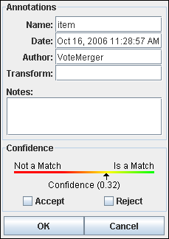
Figure 4.2 – Link Dialog
One other option available for handling links within Harmony is the ability to annotate links. This is done through the Link Dialog mentioned above. Here, the user can view the name of this link, the creation date of this link, the author of this link, the transformation required for this link to tie together the source and target nodes, and any notes that would like to be made about this link. The name, date, and author are auto-filled on creation of new links, but may be edited through this dialog. Transformations and notes can only be added and edited through this dialog.

6. Importing/Exporting Options
Once Harmony has been used to generate a mapping between source and target schemas, there are several options available for extracting this information. One such option is the ability to zip up the Harmony project for transfer to another file system. One weakness of Harmony is that it was built to dynamically monitor the specified schema files for changes. But if the Harmony project file is transferred to another network, these schema files will no longer be present. Thus, the approach to be taken in such a case is to use the Export option to create a zipped Harmony project file. This automatically zips together the Harmony project with current versions of all specified schema files. Upon transfer, one only has to unzip this file and have Harmony open the unzipped Harmony project file. A series of dialogs will then help the user reconnect the schema files with the project. The other exporter currently available recreates the schema linkages as an Excel spreadsheet containing a 2-dimensional mapping between the source and target nodes. An importer is also available for this transformation which can bring this 2-dimensional mapping back into Harmony. Additional importers and exporters can be added by users as well. Instructions on doing so can be found in Appendix 1.

Appendix 1: Extending Harmony
Harmony was built to be extensible, so that it could easily be modified to fit a wide variety of schema matching scenarios. There are five such tools which can be created: schema loaders, match voters, vote mergers, importers, and exporters. Each will be discussed in a little detail before a final discussion occurs on how to push these tools into the Harmony environment.

A. Schema Loader

This tool is used to transform schema files into the internal schema model used by Harmony. To create a Schema Loader, one must use the following interface:
public interface SchemaLoader extends Tool
{
public ArrayList<String> getFileTypes();
public void initialize(URI schema) throws IOException;
public ArrayList<String> getRootElements();
public ArrayList<String> getChildElements();
public ArrayList<URI> getDependantURIs();
public Schema generate(ArrayList<String> elements);
}

ArrayList<String> getFileTypes ()
- Returns a list of all file types which this convert can handle.

void initialize (URI schema)
- Handles any initialization steps which are required for loading in the specified schema. This is guaranteed to run prior to the running of “getRootElements”, “getChildElements”, “getDependantURIs”, and “generate”.

ArrayList<String> getRootElements ()
- Returns a list of all elements in this schema which are not descendants of any other element in the schema.

ArrayList<String> getChildElements ()
- Returns a list of all elements in this schema which are descendants of at least one other element in the schema.

ArrayList<URI> getDependantURIs ()
- Returns a list of all URIs upon which the schema is dependant.

Schema generate (ArrayList<String> elements)
- Generates a Harmony schema object which contains all of the specified top-level elements. To create this schema, create a schema object and then add nodes as necessary.

B. Match Voter

This tool is used to generate confidence scores for a specified group of source/target linkages. To create a match voter, one must use the following interface:
public interface MatchVoter extends Tool
{
public String getName();
public Double[] match(URI links[]);
public void stop();
}

String getName ()
- Returns the name of this match voter

Double[] match (URI links[])
- Returns a list of confidence scores for the specified links. Use functions from Workbench.getBlackboard() to gather all necessary information for matching.

void stop ()
- If called, an immediate shutdown of the match routine must occur

C. Vote Merger

This tool is used to merge together the confidence scores of match voters for a specified group of source/target linkages. To create a vote merger, one must use the following interface:
public interface Matcher extends Tool
{
public String getName();
public void match(URI links[], ArrayList<MatchVoter> voters);
public void stop();
}

String getName ()
- Returns the name of this vote merger

void match (URI links[], ArrayList<MatchVoter> voters)
- Merges together the confidence scores for the specified voters run on the specified links. Resultant confidence scores can be stored in the model with the function Workbench.getBlackboard().setMappingCellConfidence().

void stop ()
- If called, an immediate shutdown of the match routine must occur

D. Importer

This tool is used to import a project from a specified format. To create an importer, one must use the following interface:
public interface Importer extends Tool
{
public FileFilter getFileFilter();
public void importFrom(File f) throws IOException;
}

FileFilter getFileFilter ()
- Provides a file filter for selecting file types compatible with this importer.

void importFrom (File f)
- Imports the project from the specified file. Use functions from Workbench.getBlackboard() to generate the necessary information in the model.

E. Exporter

This tool is used to export a project into a specified format. To create an exporter, one must use the following interface:
public interface Exporter extends Tool
{
public String getFileType();
public FileFilter getFileFilter();
public void exportTo(File f) throws IOException;
}

String getFileType ()
- Returns the file type associated with this exporter.

FileFilter getFileFilter ()
- Provides a file filter for selecting file types compatible with this exporter.

void exportTo (File f)
- Exports the project to the specified file. Use functions from Workbench.getBlackboard() to retrieve the necessary information from the model.

To install any of these tools into the Harmony framework is a simple three step process. First, one must place the class somewhere within the Harmony project directory. By convention, all tools which have already been created have been placed within the org.mitre.wc3.w909.workbench.tools branch of the project. The second step is to define the tool within the Harmony environment. To do this, open up “harmony.tools.xml” found in the top directory of the Harmony project. All that needs to be done here is to add a new <tool> attribute which indicates the location of the new tool class. And the final step requires restarting Harmony. Once done, the tool should be present for use within Harmony.

P. Mork, A. Rosenthal, L. J. Seligman, J. Korb, and K. Samuel, "Integration Workbench: Integrating Schema Integration Tools," presented at InterDB'06 Second International Workshop on Database Interoperability, Atlanta, GA, 2006.

